User Guide

jWebSocket
Monitoring resources of computers
Orlando Miranda Gómez

1. Characteristics of the solution
The monitoring demo allows users to set up a stable and continuous monitoring of the resources of a computer in real time. You can view the status of resources from a computer or from a cell phone, just having a web browser that supports WebSocket protocol, which provides high speed and real-time work. Was developed with the framework jWebSocket.
This demo in addition to everything stated above provides a high level of safety, and notifies the user of the computer by email, if there is a high consumption of some of the resources thus ensuring that there is no failure or spoilage.
2. Main functionalities
- Show the state of the RAM and Swap memories.
- Show the consumption of the microprocessor in percent.
- Show the used and free space of the hard disc. This space is in the partition where is installed the operating system.
- Notifie by e-mail.
Monitoring Demo can be used in any sector of society and that is very important in protecting the components of a computer by using the web, ensuring greater availability of Web services providing by the computer. As one of the biggest advantages is that it can be viewed from anywhere in the world, just having an internet connection from any mobile device as both stationary.
3. Problems to be solved
Problem | Contributions of the solution
Statistical monitoring of resources on the Web. | Monitoring Demo is an application that enables continuous display of state resources in real time.
4. Glossary of Terms
Real-time work: It is possible when the client receives messages from the server without prior request and end users receive updates simultaneously.
RAM: Random Access Memory.
Swap: Interchange Memory.
- Model of the solution
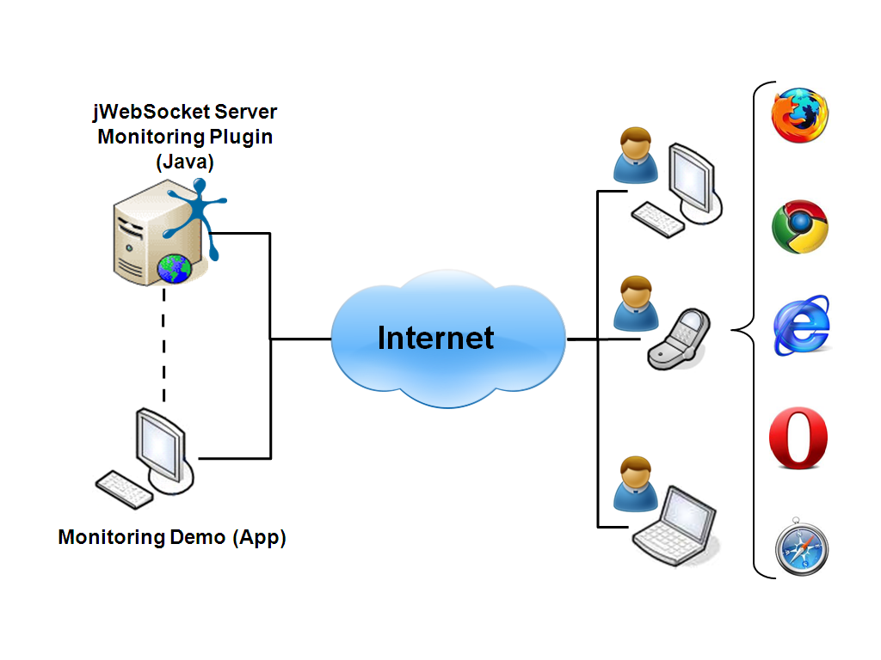To access the Monitoring Demo application is only required the user to use a browser that supports WebSocket protocol. Then the application must authenticate to access the information it provides. This way you can monitor your computer or laptop from any other and from a cell phone where the information will be sent by the server jWebSocket, which is installed on your computer.
7. Requirements for the use
To use Monitoring Demo must have Internet access and use any of the browsers that support the WebSocket communication protocol. Some of them are Google Chrome 4 +, Safari 5 +, Mozilla Firefox8 +, Opera 11+ and Internet Explorer 10 +.
8. Roles of the solution
System User: interacts with the application to observe the operation of resources.
9. System Operation
Initial and main view of the application: allows users with permissions can authenticate to the application and you can get the desired data.
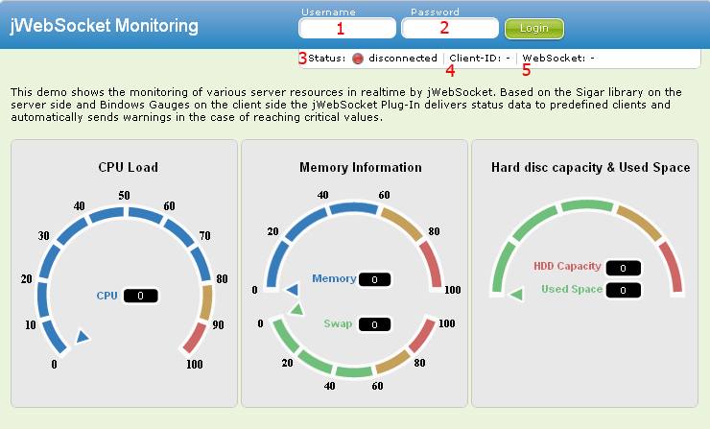
1-> Field to insert the user to authenticate to the application..
2-> Field to insert the password.
-> To access the application.
3-> Displays the status of the application (Authenticated / Offline).
4-> Display the id of the logged user.
5-> Displays protocol information.
Main view of the aplication: connected users can view the resources information in real time.
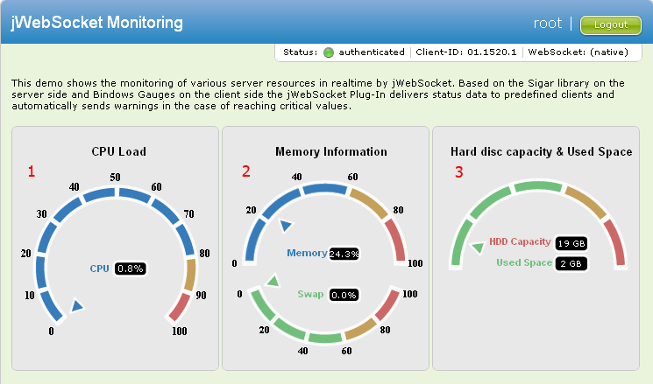
1-> Displays information about the microprocessor in percent.
2-> Displays information of the memory RAM and Swap in percent.
3-> Displays the capacity and used space of the hard disc.
-> Exits of aplication.

9. Configurations of the solution
In this application is not made settings or customizations that provides the solution.
10. Rules of the solution
R1: If the user mistypes your username or password, during Access to application, the system issues an error message and does not continue with the normal flow. Solution: The user must repeat the username and password.

